How To Make Your Milk Jug Trash Collector
(Courtesy of I Love A Clean San Diego)

Materials Needed:
- Plastic 1-gallon milk or water jug with handle
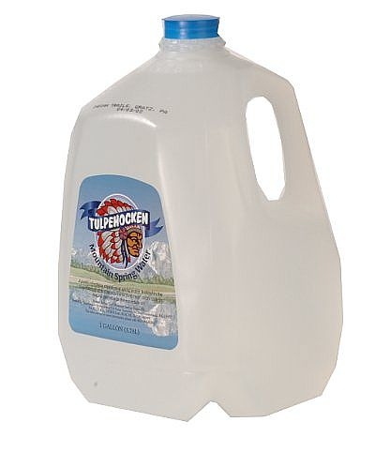
- Scissors



Directions:
Step 1: Wash and dry plastic jug
Step 2: With the scissors, make an incision at the top of the jug below the neck and above the handle. Cut off the top of the jug in an oval shape (see picture below) without cutting the jug’s handle. Cut the plastic jug on a stable surface in order to prevent any accidents.

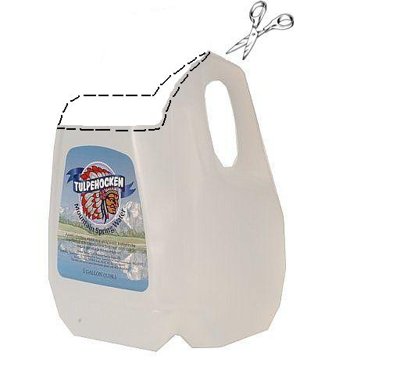
Step 3: Go clean the beach! You are now ready to use your plastic jug as a collector for cigarette butts and other small pieces of trash you may find on the sand.

